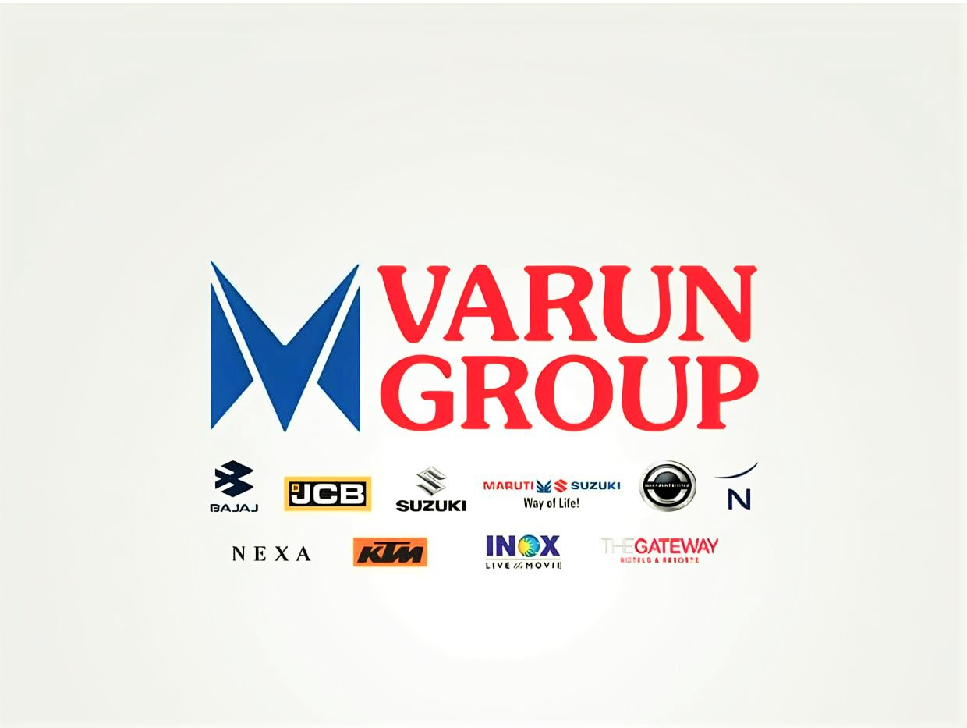
Suzuki True Value – SRS Document

Document Control

Document Information
© | Information
Document Description | SRS document for developing a new software System True Value (Maruti Suzuki Division
Document Owner | Sandeep Kondapalli – MA016945
Document version | 1.0 (Initial Version)
Issue Date | 19-05-2026
Last Saved Date
File Name

Document History
Version | Issue Date | Changes
[1.0] |  | Initial Draft

Document Approvals
Role | Name | Signature© | Date
Project Head

Project Review Group

Project Manager

Introduction

Purpose
The purpose of this document is to define the Software Requirement Specification (SRS) for the True value – Used Vehicle Exchange & Sales Platform developed for Varun Group. The application is intended to digitize and centralize the complete lifecycle of used vehicle exchange, valuation, refurbishment, resale, documentation, and delivery management.
In This module application should handle the activities that are performed by true value department, this mainly includes with the purchase of used cars from customers or other individuals, application should capture the sales activities of used cars with the following modes (used car to new car/ used car to used car/ used car to direct purchase). In addition, application should handle the purchases, Profit & loss statements, stock management, docket management, refurbishment workflows.

Project Scope
  - – Sales: This module is about sales booking process by extracting enquiry data from True Value portal, web enquiries, Hyperlocal (Tele calling), and Direct true value showroom walkin’s. Application needs to capture all stages of workflows. In this used cars management customer’s vehicle selection and price negotiation are two important factors for used car sales. In addition there are other key functionalities - booking management, financial module, vehicle test drive, accessories, Invoicing, vehicle delivery (gate out).

  - – Purchases: In used car management, purchasing is a process of buying a used car, by acquiring the ownership rights to that vehicle from the seller. This process involves transferring the ownership of the vehicle from the seller's name to the buyer's name (Maruti True value). The purchase process involves negotiation, documentation, payment, and compliance with legal and regulatory requirements for maintaining a quality used cars for resale.

  - – Refurbishment: This is a process of renovating or restoring a used vehicle to improve its overall condition and appearance before offering it for sale. Refurbishment includes activities aimed at enhancing the vehicle's appearance, performance, and safety features. Some of the refurbishment used for vehicle enhancement are painting works/ interior & exterior detailing/ engine repairs/ Tyres replacement/ electrical application checking’s/ quality Control .
  - – Docket Management: This sub module is about customer booking documentation process. In the docket management sales person handles all the customers related documents for vehicle booking. docket management contains Customer KYC documents like (PAN & Aadhar) /bank loan clearance documents( if customer opts for finance)/ photo copies/receipts / accessories details / Transfer token & Digital Thumb process documents/Added services/ vehicle related documents . each docket is a unique for every customer.

  - – Profit &Loss Statement: Profit & Loss (P&L) statement for a used car management involves detailing the revenues and expenses associated with buying, refurbishing, and selling used cars. P&L statement for a used cars management business are- Total revenue from selling used cars, cost of cars sold, Total cost of refurbishing and repairing used cars for resale, operating expenses, marketing and advertisement.

Intended Audience & Reading Suggestions
The document is intended for:
- Developers
- Business Analysts
- QA/Test Teams
- Project Managers
- Management Stakeholders
- Operational Users
- Technical Writers
- Deployment & Infrastructure Teams

Reading Suggestions
Audience | Suggested Focus
Developers | Functional requirements, workflow logic, APIs, validations
QA Teams | Business rules, validations, workflow conditions
Project Managers | Scope, milestones, modules, dependencies
Business Teams | Operational workflows and approval hierarchy
Management | Reporting and profitability analytics

2. Overall Description

2.1 Product Perspective
V-Promise is a centralized used vehicle management application designed to digitize the exchange and resale operations performed by Varun Group.
The application shall support:
- Customer exchange lead lifecycle
- Vehicle inspection workflows
- Valuation approvals
- Used vehicle inventory tracking
- Reconditioning operations
- Vehicle resale process
- Payment tracking
- RC transfer tracking
- Margin analysis dashboards
The application shall support both Android mobile interfaces and web interfaces.

2.2 User Classes and Characteristics
User Role | Responsibilities
Sales Executive | Create exchange leads, upload documents, initiate inspections
Inspection Executive | Perform digital inspection and grading
Valuation Manager | Approve/revise valuation
Inventory Manager | Manage used stock and reconditioning
Admin | User management and configuration
Management Users | Reporting and analytics

2.3 Operating Environment
The application shall support:
- Android Mobile Devices
- Web Browsers (Chrome, Edge)
- Cloud-based centralized database
- REST API architecture
- Multi-branch operational access

2.4 Assumptions and Dependencies
- Internet connectivity must be available for synchronization.
- Users must have valid login credentials.
- Branch master data must be configured.
- Vehicle valuation policies must be approved by management.
- Document storage infrastructure must be available.

3. Application Features
3.1 Used cars management: In this functional module, application show captures the used cars sales management working flow, which is Maruti -True value. There are majorly 4 categories of working flows in this used cars management which are regularly processed in daily operations-

- Exchange process (old to new car)
- Selling process of used vehicles to the customers
- Purchase of used cars

There will be a multiple enquiry sources for this used cars management, which may be for buying, resales, exchanges. These enquiry leads will come from tele calling, direct showroom walk-in, or website enquiries. Based on 370+ true value checkpoints a vehicle are categorized into 1.True value vehicle or 2. Non- true value cars. All Suzuki brands will come under True value and non-Suzuki brands will come under Non-true value cars, if any vehicle ageing condition which exceeds BSES norms that will come to this NT category (including Suzuki cars).

Therefore, application should consider the sequential workflow steps with all related data points in this used cars management module.

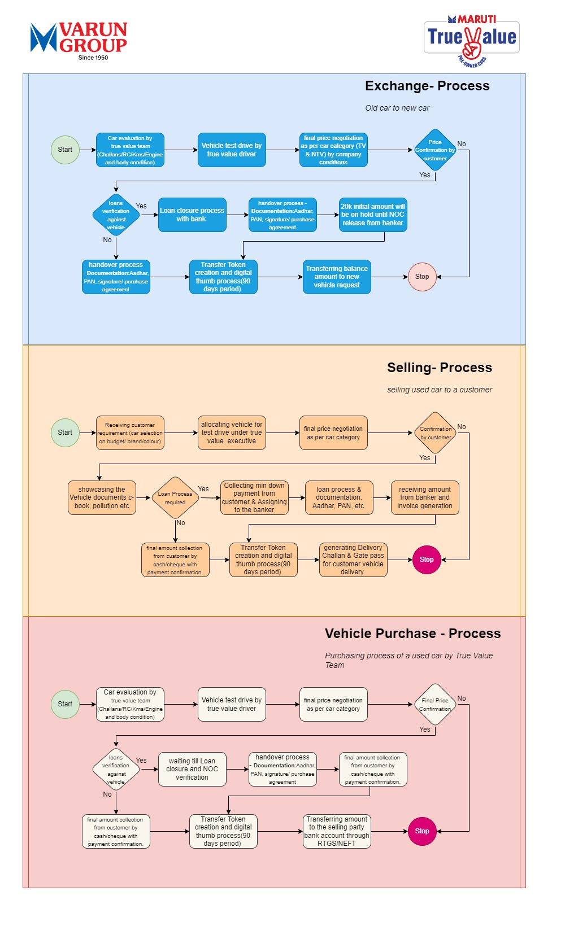
Exchange process workflow

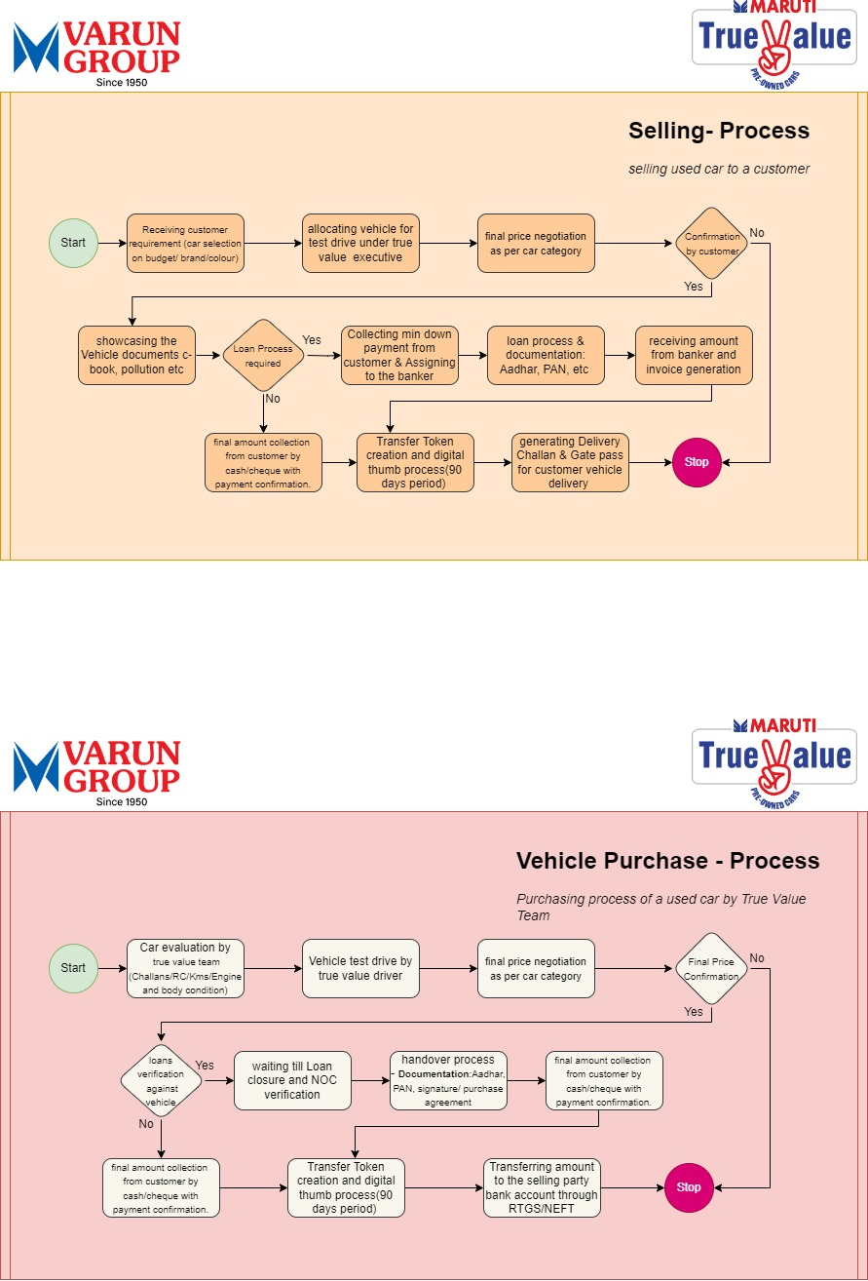

Selling process workflow & Purchase process workflow

Used Cars Management Sales
3.23– Sales
This is about sales booking process of used cars management by the reference of sales enquiry from True Value portal, web enquiries, Hyperlocal (Tele calling), and Direct true value showroom walk-in’s.
Functional Requirement
FR Ref.# | Actor |  | Functional Requirement
FR- 3.23.1 | Sales Person |  | Sales person uses this screen interface to book the customer order against a booking enquiry
FR- 3.23.2 | Vehicle |  | Vehicle details should be available in this business structure for creating the booking request.
FR- 3.23.3 | Customer |  | Customer will provide the personal information and requirement with model/color/price to purchase the vehicle
Pre-Requisite
Pre-Req.# |  | Pre- Requisite
PR- 3.23.1 |  | Customer details – Customer basic details has to be mapped against enquiry number during the time of booking enquiry creation
PR- 3.23.2 |  | Vehicle details – vehicle details (Model/variant/color/price) has to be available for selection during the time of sales booking
Business Rules
BR-Ref.# |  | Business Rule
BR- 3.23.1 |  | Application should display only listed vehicle, which is in good condition, with the applied filter criteria like- (cost budget/model/year of manufacture/vehicle age/color)
BR- 3.23.2 |  | Every used vehicle must undergo a comprehensive inspection (transfer certificate with all related clearance of document from previous owner) before listed for sale.
BR- 3.23.3 |  | Application should capture complete Vehicle history data with transparency with previous ownership data (year of purchase/no. of Kms travelled, services performed, engine condition. .)
BR- 3.23.4 |  | Every used vehicle should be categorized clearly as maruti true value or non-true value (other than maruti brand) by clearing all 370+check points. During the time of selling process
BR- 3.23.5 |  | There should be a provision to upload Customer KYC documents during the time of bookings.
BR- 3.23.6 |  | Application should Safeguards with critical business data, ensuring continuity of operations and preventing information loss.
BR- 3.23.7 |  | Financial opting provision should enables for providing financing options. This financial application status has to be tracked till the payments clearance done from the customer side

Used Cars Management Purchases
3.24– Purchases
This feature is used to manage the purchase of used vehicles from customers or other individuals. The purchase process includes seller information capture, vehicle inspection, valuation, negotiation, purchase approval, payment processing, ownership transfer documentation, and stock-in entry into True Value inventory.
Functional Requirement
FR Ref.# | Actor |  | Functional Requirement
FR- 3.24.1 | Sales Person/True Value Executive |  | To create used vehicle purchase enquiry from customer or seller.
FR- 3.24.2 | Inspection Executive |  | To inspect the vehicle and capture vehicle condition details.
FR- 3.24.3 | Valuation Executive |  | To enter proposed purchase value based on inspection and market value.
FR-3.25.4 | Purchase Manager |  | To approve or revise final purchase value.
FR-3.25.5 | Accounts Team |  | To process seller payment after approval and document verification.
FR-3.25.6 | Inventory Team |  | To create stock-in entry after purchase completion.
FR-3.25.7 | Documentation Team |  | To collect and verify ownership transfer documents.
Pre-Requisite
Pre-Req.# |  | Pre- Requisite
PR- 3.24.1 |  | customer details must be available with valid mobile number and address details.
PR- 3.24.2 |  | Vehicle registration number, chassis number, engine number, model, variant, year, fuel type, and odometer details must be available.
PR- 3.24.3 |  | Vehicle documents such as RC, insurance, pollution certificate, Form 29/30, ID proof, and address proof must be collected.
PR- 3.24.4 |  | Vehicle inspection checklist must be configured in the application.
PR- 3.24.5 |  | Valuation approval hierarchy must be configured.
PR- 3.24.6 |  | Payment mode and accounts approval process must be available.
PR- 3.24.7 |  | Branch and stock location must be configured before stock-in.
Business Rules
BR-Ref.# |  | Business Rule
BR- 3.24.1 |  | Every used vehicle purchase enquiry must generate a unique purchase enquiry number.
BR- 3.24.2 |  | Vehicle registration number and chassis number should be validated to avoid duplicate purchase records.
BR- 3.24.3 |  | Vehicle purchase process should not proceed without mandatory seller details and vehicle details.
BR- 3.24.4 |  | Vehicle inspection must be completed before valuation entry.
BR- 3.24.5 |  | Inspection checklist should capture exterior, interior, engine, transmission, tyres, battery, accident history, odometer, and document condition.
BR- 3.24.6 |  | Application should support photo upload for vehicle front, rear, left, right, interior, odometer, engine bay, chassis plate, and damages.
BR- 3.24.7 |  | Valuation amount should be entered only by authorized valuation users.
BR- 3.24.8 |  | Final purchase value should be approved by Purchase Manager/Valuation Manager before payment processing.
BR- 3.24.9 |  | Seller payment should not be processed until valuation approval and mandatory document verification are completed.
BR- 3.24.10 |  | Cancelled purchase records should remain in history and should not be deleted permanently.

Used Cars Management Refurbishment
3.25– Refurbishment
This feature is used to manage the refurbishment or reconditioning process of purchased used vehicles before resale. Refurbishment activities include mechanical repairs, painting works, interior and exterior detailing, tyre replacement, battery replacement, electrical checking, service work, quality control, and final readiness certification.
Functional Requirement
FR Ref.# | Actor |  | Functional Requirement
FR- 3.25.1 | Inventory Manager |  | To initiate refurbishment request against purchased used vehicle.
FR- 3.25.2 | Service Advisor |  | To create refurbishment job card with required repair details.
FR- 3.25.3 | Technician/Workshop Team |  | To update work progress and completion status.
FR- 3.25.4 | Purchase/Inventory Team |  | To track refurbishment cost against vehicle.
FR- 3.25.5 | Quality Control Team |  | To verify final vehicle readiness after refurbishment.
FR- 3.25.6 | Management |  | To view refurbishment cost and aging reports.
Pre-Requisite
Pre-Req.# |  | Pre- Requisite
PR- 3.25.1 |  | Vehicle must be purchased and available in used vehicle stock.
PR- 3.25.2 |  | Initial inspection report must be available.
PR- 3.25.3 |  | Refurbishment category master must be configured such as mechanical, electrical, body shop, detailing, tyres, battery, and painting.
PR- 3.25.4 |  | Workshop/service team users must be configured with valid roles.
PR- 3.25.5 |  | Cost heads and expense categories must be available for cost booking.
PR- 3.25.6 |  | Quality control checklist must be configured.
Business Rules
BR-Ref.# |  | Business Rule
BR- 3.25.1 |  | Refurbishment request should be created only for vehicles available in purchased stock.
BR- 3.25.2 |  | Every refurbishment request must generate a unique refurbishment/job reference number.
BR- 3.25.3 |  | Application should allow refurbishment activities such as painting, interior detailing, exterior detailing, engine repair, tyre replacement, battery replacement, electrical checking, and quality control.
BR- 3.25.4 |  | Refurbishment cost should be captured activity-wise and vehicle-wise.
BR- 3.25.5 |  | Labour cost and material cost should be captured separately.
BR- 3.25.6 |  | Any additional repair identified during refurbishment should be added with remarks and approval.
BR- 3.25.7 |  | Vehicle status should update dynamically as Refurbishment Pending/In Progress/Completed/QC Pending/Ready for Sale.
BR- 3.25.8 |  | Vehicle should not be available for sale until QC approval is completed.
BR- 3.25.9 |  | Refurbishment completion date should be captured for stock aging and readiness reports.
BR- 3.25.10 |  | Refurbishment cost should automatically reflect in Profit & Loss calculation.

Used Cars Management Docket Management
3.26– Docket Management
This feature is used to maintain customer, seller, vehicle, finance, payment, delivery, and ownership transfer documents for used vehicle transactions. Each used vehicle purchase or sale transaction should have a unique docket record.

Functional Requirement
FR Ref.# | Actor |  | Functional Requirement
FR- 3.26.1 | Sales Person |  | To upload customer KYC and booking related documents.
FR- 3.26.2 | Purchase Executive |  | To upload seller and vehicle purchase documents.
FR- 3.26.3 | Finance Team |  | To upload loan and bank related documents if customer opts for finance.
FR- 3.26.4 | Documentation Team |  | To upload RC transfer, Form 29/30, transfer token, and digital thumb documents.
FR- 3.26.5 | Manager |  | To verify docket completion status.
FR- 3.26.6 | System |  | To maintain unique docket against each transaction.
Pre-Requisite
Pre-Req.# |  | Pre- Requisite
PR- 3.26.1 |  | Customer booking or purchase reference number must be available.
PR- 3.26.2 |  | Customer/seller KYC documents must be available.
PR- 3.26.3 |  | Vehicle documents such as RC, insurance, pollution certificate, and service history must be available.
PR- 3.26.4 |  | Finance documents must be available if finance option is selected.
PR- 3.26.5 |  | Document category master must be configured.
PR- 3.26.6 |  | User access permissions must be configured for upload, view, verify, and approve actions.
Business Rules
BR-Ref.# |  | Business Rule
BR- 3.26.1 |  | Each used car transaction must have a unique docket number.
BR- 3.26.2 |  | Docket should be mapped to purchase reference number or sales booking reference number.
BR- 3.26.3 |  | PAN and Aadhaar documents should be mandatory for customer/seller KYC verification.
BR- 3.26.4 |  | RC copy should be mandatory for purchase and sale transaction closure.
BR- 3.26.5 |  | Finance documents should be mandatory only when customer opts for finance.
BR- 3.26.6 |  | Application should support document upload formats such as PDF, JPG, JPEG, and PNG.
BR- 3.26.7 |  | Document verification status should be maintained as Pending/Verified/Rejected/Re-upload Required.
BR- 3.26.8 |  | Rejected documents should capture rejection reason and should notify concerned user for re-upload.
BR- 3.26.9 |  | Authorized users should have view/download access based on role permissions.
BR- 3.26.10 |  | Ownership transfer closure should not be allowed without required transfer documents.

Used Cars Management Profit & Loss statement
3.27– Profit & Loss statement
This feature is used to calculate and display Profit & Loss details for each used vehicle transaction. The P&L statement should include purchase cost, refurbishment cost, accessories cost, operating expenses, marketing expenses, sale value, discounts, taxes, and final gross/net margin.
Functional Requirement
FR Ref.# | Actor |  | Functional Requirement
FR- 3.27.1 | Accounts Team |  | To verify purchase cost, sale value, expenses, and margin details.
FR- 3.27.2 | Inventory Manager |  | To view vehicle-wise cost and profitability.
FR- 3.27.3 | Sales Manager |  | To review sale margin before final approval if required.
FR- 3.27.4 | Admin/ GM |  | To view branch-wise, vehicle-wise, and executive-wise P&L reports.
FR- 3.27.5 | System |  | To auto-calculate gross margin and net profit/loss.
Pre-Requisite
Pre-Req.# |  | Pre- Requisite
PR- 3.27.1 |  | Vehicle purchase value must be available.
PR- 3.27.2 |  | Refurbishment cost must be captured and approved.
PR- 3.27.3 |  | Sale value and invoice details must be available.
PR- 3.27.4 |  | Accessories cost, added services, and other expenses must be captured if applicable.
PR- 3.27.5 |  | Discount and negotiation approvals must be available if sale price is revised.
Business Rules
BR-Ref.# |  | Business Rule
BR- 3.27.1 |  | P&L statement should be generated vehicle-wise.
BR- 3.27.2 |  | Application should calculate gross margin as sale value minus purchase value and refurbishment cost.
BR- 3.27.3 |  | Application should include purchase cost, refurbishment cost, accessories cost, marketing cost, operating expenses, discounts, and sale value in P&L.
BR- 3.27.4 |  | Refurbishment cost should be auto-fetched from refurbishment module.
BR- 3.27.5 |  | Closed P&L statement should not be modified
BR- 3.27.6 |  | P&L reports should be downloadable in Excel/PDF format.
BR- 3.27.7 |  | Profit and loss values should be visible only to authorized users.
BR- 3.27.8 |  | Application should maintain complete audit log for all cost and margin changes.

4. Dashboard & Reporting

Description
This module provides operational dashboards and MIS reports.
Functional Requirements
FR Ref# | Actor | Functional Requirement
FR-3.10.1 | Management | View inventory aging reports
FR-3.10.2 | Management | View gross margin analytics
FR-3.10.3 | Branch Managers | View executive performance
FR-3.10.4 | System | Export reports in Excel/PDF

Business Rules
BR Ref# | Business Rule
BR-3.10.1 | Dashboard data should refresh dynamically
BR-3.10.2 | Reports should support branch-wise filtering
BR-3.10.3 | Exported reports should include timestamps
BR-3.10.4 | Inventory aging should calculate based on stock-in date
BR-3.10.5 | Only authorized users can view financial reports

User & Role Management
This module handles user creation, role assignment, and access permissions.
Functional Requirements
FR Ref# | Actor | Functional Requirement
FR-3.11.1 | Admin | Create users
FR-3.11.2 | Admin | Assign branch and role
FR-3.11.3 | System | Enforce access permissions

Business Rules
BR Ref# | Business Rule
BR-3.11.1 | Every user must have unique login ID
BR-3.11.2 | Password policy should follow security standards
BR-3.11.3 | Deactivated users should not access the application
BR-3.11.4 | Role-based screen visibility should be enforced
BR-3.11.5 | Login activity must be audit logged

External Interface Requirements
- Android mobile interface
- Responsive web application
- Dashboard analytics interface
- Approval workflow screens

Software Interfaces
  - REST APIs
  - Payment gateway integration
  - SMS and WhatsApp notification APIs
  - Document storage APIs

Communication Interfaces
- HTTPS secure communication
- API authentication tokens
- Real-time synchronization services

Non-Functional Requirements
Category | Requirement
Performance | Response time should be within acceptable limits
Availability | Application should support high availability
Scalability | Multi-branch scalability should be supported
Security | Data encryption at rest and transit
Reliability | Audit logging and backup support
Maintainability | Modular architecture should be followed

Security Requirements
- Role-based access control
- Password encryption
- Secure API authentication
- Audit trail logging
- Data backup and recovery
- Session timeout management
- Secure document storage

Audit & Compliance
- All critical actions must maintain audit logs.
- Approval history must be preserved.
- Financial changes should capture user remarks.
- Document modification history should be maintained.
- System should support future compliance audits.

Glossary
Term | Description
RC | Registration Certificate
Exchange Lead | Customer enquiry for vehicle exchange
Stock-In | Process of adding vehicle into inventory
Reconditioning | Vehicle refurbishment process
Gross Margin | Profit difference between purchase and resale

